

Universidad de Guadalajara

Centro Universitario de los Valles

**Software Configuration Management**

Homework:

Baseline Version 1

**Master: Software Engineering**

**Third semester**

Professor: Omar Ali Zatarain Duran

Efren Plascencia JR.

222977393

Friday, September 1st, 2023

Content

Description 3

Main features 3

Input module 3

Preprocessing module 3

Processing module 3

Result module 3

Administration module 3

Requirements 4

Functional Requirements 4

Input module 4

Preprocessing module 4

Processing module 4

Result module 4

Administration module 5

No-Functional Requirements 5

Availability 5

Devices: 5

Design 5

Maintainability 5

Performance 5

Security and Privacy 5

Usability 5

Requirements Analysis 6

Design System 8

# Description

A system with the ability to identify events present in texts written in English with the ability to receive inputs in different formats such as the entries of a Wikipedia links, texts in .txt format or inputs written in the system where the events are displayed in two main ways the first through a table with all the events presents and detected by the system and the second way with a graphic representation of the relationships between events show as a timeline or graph.

## Main features

The following section shows the main features that are expected to be developed within the system.

### Input module

* Users can enter Wikipedia link and the system will fetch the data from the web site.
* Users can upload text files (.txt) where the content will be shown to the user and be able to edit the text in the system.
* User can enter text directly to the system (write and edit).

### Preprocessing module

* Creation of a set of tokens which we refer to as a sequence.
* Identification and extraction of stop words in the sequences.
* Identification and extraction of concepts in the sequence.
* Identification and extraction of operators in the sequence.
* Identification of relative and specific dates present in the sequence. (Anchors and intervals)

### Processing module

* Identification of relationships between concepts (implicit)
* Identification of relationships between concepts (explicit)

### Result module

* Tabular event reporting
* Generation of reports of events graphically (timeline / graph)

### Administration module

* Management of users and documents processed for storage.

# Requirements

In this section we show the requirements for the system based on the main featured described in the description of the system, we classified by functional and non-functional. Where we will use the acronyms FR to refer to functional requirements and NFR for non-functional requirements.

## Functional Requirements

### Input module

FR 1: The system will be able to receive text files.

FR 2: The system will be able to show data from the text files to the user.

FR 3: The system will be able to tolerate changes in the data from the data.

FR 4: The system will be able to receive Wikipedia links by the user.

FR 5: The system should be able to fetch the Wikipedia links.

FR 6: The system should be able to get the Wikipedia without HTML and CSS tags (web scrapping)

FR 7: The system will be able to receive data written in the system by the user.

### Preprocessing module

FR 1: The system will be able to create a sequence of tokens.

FR 2: The system will be able to identify stop words in the sequence.

FR 3: The system will be able to identify concepts in the sequence.

FR 4: The system will be able to identify operators in the sequence.

FR 5: The system will be able to identify relative and specific dates in the sequence.

### Processing module

RF 1: The system will be able to identify relationship between concepts explicit with anchors or intervals.

RF 2: The system will be able to identify relationships between concepts implicit with anchors or intervals.

### Result module

FR 1: The system will be able to generate tables representing the concepts and the relationships between concepts.

FR 2: The system will be able to generate tables representing the isolated concepts.

FR 3: The system will be able to generate reports of concepts with a graph.

FR 4: The system will be able to generate reports of concepts with timelines.

### Administration module

The following requirements are specified for the web version.

FR1: User must be able to create account by providing their personal information such as full name, email, username, and password.

FR2: User should be able to edit their personal information and contact information.

FR3: User should be able to log in using their registered credentials.

FR4: Users should be able to recover forgotten password through a reset process.

FR5: The system must validate the uniqueness of email to avoid duplicate registration.

FR6: The system must verify the authenticity of the email during the registration process.

FR7: The system should be able to save files and the result of the analysis performed if the user wishes.

## No-Functional Requirements

### Availability

NFR 1: The system must be available most of the time for the needs of the final user.

### Devices:

NFR 1: The program must work consistently across different operating systems (Windows or Linux).

NFR 2: The program must work consistently across different internet browsers.

### Design

NFR 1: Responsive user interface for use on desktop and web applications.

NFR 2: The system must allow informative messages about errors.

### Maintainability

NFR 1: The code source should be well structured in some pattern of software development to facilitate future update and changes.

NFR 2: Documentation on the code and architecture to facilitate maintenance by future developers.

### Performance

NFR 1: Loding time should be adequate to avoid user frustration.

NFR 2: Processing time for texts needs to be the more efficient possible.

### Security and Privacy

NFR 1: The system must follow regulations and privacy standards.

NFR 2: The system access must have some security mechanisms.

### Usability

NFR 1: User interface must be intuitive and easy to navigate for the final user.

# Requirements Analysis

In this section, we analysis the requirements and we present a use case diagram for the general representation of main actors that intervene in the system with the intention demonstrating the purpose for the system and the understanding for the development team and the stakeholders.

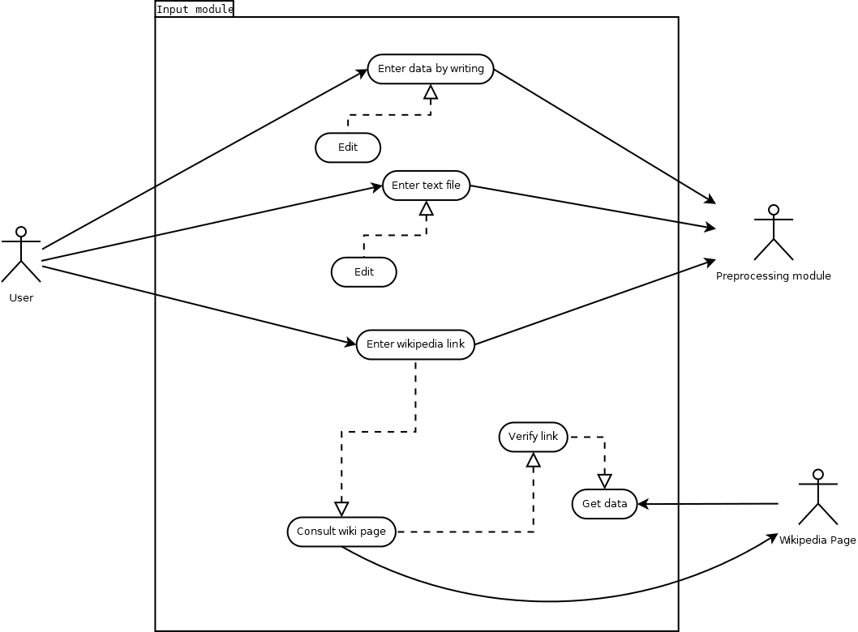

Figure 1 Use case diagram input module.

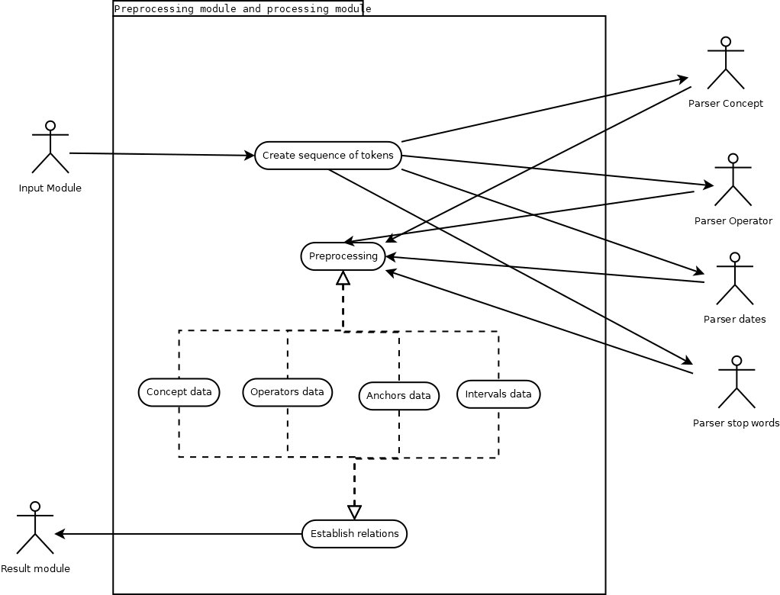

Figure 2 Use case diagram preprocessing and processing module.

# Design System

In this section, we describe the flow of the system figure 3 where it seeks to show the different stages involved in the system.

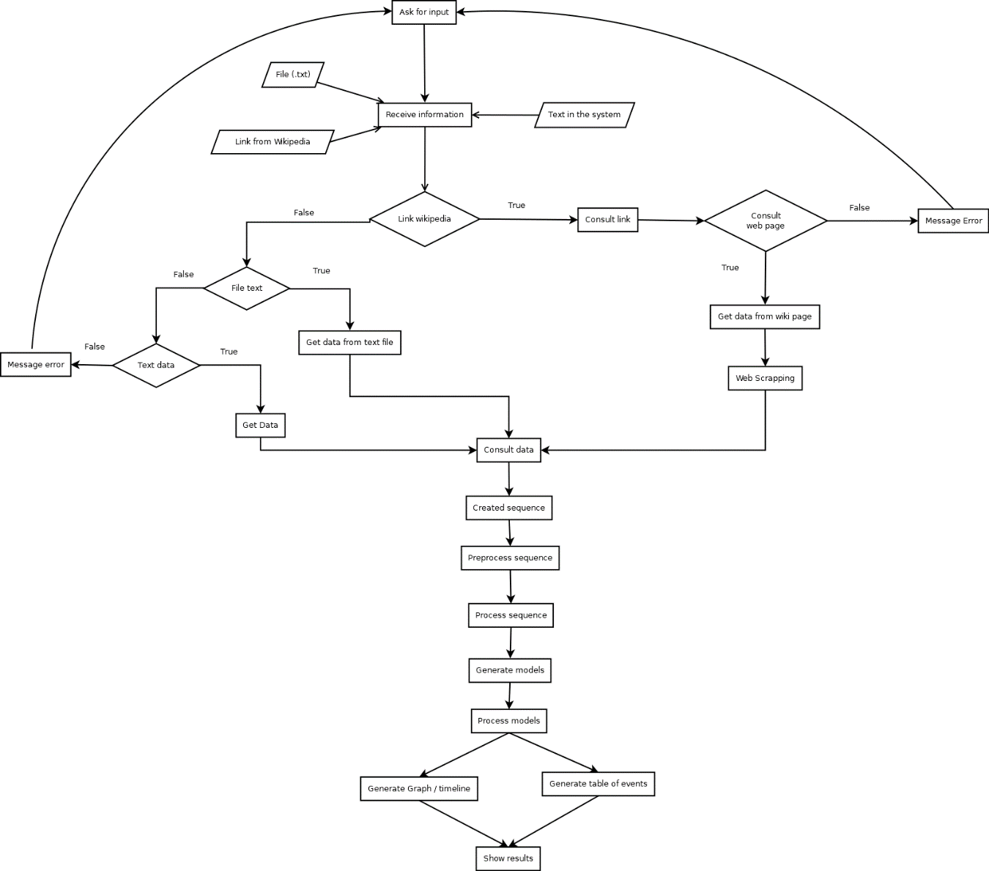

Figure 3 Flowchart of the system.